100% Infill stress-strain comparison

Note: the chi-squared is significant (p<0.05)

Interesting to see that the repaired have a higher young’s modulus

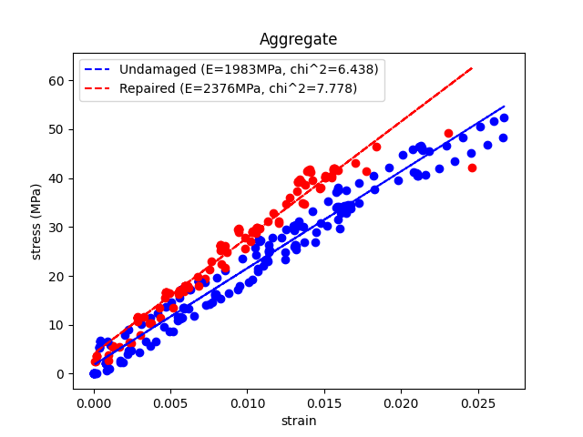

Comparison of maximum load able to be held (box and whisker).

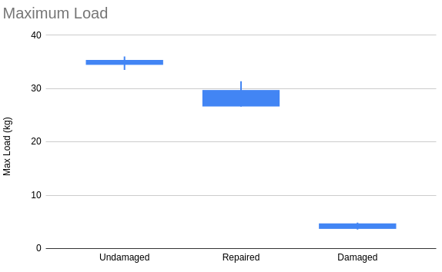

In a more tabulated way

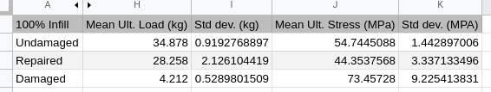

All 100% infill tests on a single plot

